Project Initialization and Planning Phase

Date | 15 March 2024
Team ID | 739868
Project Name | Real Time Communication System Powered By AI For Specially Abled
Maximum Marks | 3 Marks

Define Problem Statements (Customer Problem Statement Template):

Effective communication is a fundamental aspect of daily life, yet individuals with speech and hearing impairments often face significant challenges in expressing themselves or understanding others in real-time scenarios. Despite advancements in assistive technologies, there is a gap in providing seamless and efficient communication tools that cater to their specific needs. Real-time communication systems powered by AI can bridge this gap by translating sign language or other non-verbal cues into text or speech and vice versa. This tool can empower specially-abled individuals to engage in everyday activities, participate in conversations, and interact with the world more confidently and inclusively.

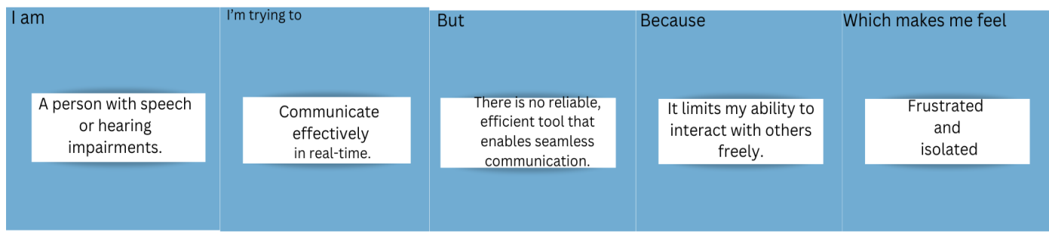

Problem  Statement (PS) | I am  (Customer) | I’m trying to | But | Because | Which makes me feel
PS-1 | A person with speech or hearing impairments. | Communicate effectively in real-time. | There is no reliable, efficient tool that enables seamless communication. | It limits my ability to interact with others freely. | Frustrated and isolated.
PS-2 | A caregiver or educator for specially-abled individuals. | Facilitate smooth interaction and understanding. | Traditional methods of communication are slow and not user-friendly. | It reduces the quality of care or education I can provide. | Inefficient and unable to support their needs fully.

